# Unit xxx

# Lexical resource

|  |
| --- |
| [ɪn'teɪl]  1.　to involve something as a necessary part or result 使必要；需要  •A new computer system **entails** a lot of re-training. 使用新的计算机系统需要大量的再培训。  •Some foreign travel is **entailed** in the job. 做这份工作有时要到国外出差。  entail doing sth  •The journey will entail changing trains twice. 这趟旅程要转两次火车。  e.g. Can I ask what this job **entails** 这个工作都包括什么?  Sure, What would my job **entail**? 　是的，我的工作都包括什么？  e.g. How many (hours/ reports/ meetings) a week **does the job entail**?  这项工作需要一个星期（工作多少个小时/写多少报告/开多少次会）  2. old use if you entail property, you arrange for it to be given to a specific person, usually your oldest son, when you die　遗赠〔财产〕；限定继承 |
| [激增 a surge in growth ］  e.g. China will have seen **a surge in growth** 激增by next year. |
| royalty: n. 皇室王权；版税/专利税  e.g. Finding quality royalty-free photographs, especially of cut out people that you can  use throughout your lessons as learner guides, is always a challenge. Fortunately,  Captivate comes with a wonderful assortment of Characters (via the Media tool).  There are multiple Character categories (such as Business and Medicine). Each  category contains multiple models and poses. |
| rogue [a rogue nation 流氓国家 ]  [rəʊg] 美 [roɡ]  n. 流氓；小淘气；凶猛的离群兽；（尤指植物的）劣种 vi. 游手好闲；去劣；流浪  e.g DPRK is a rogue nation 流氓国家  e.g.perhaps a rogue小淘气 boy has doodled on the wall |
| ['kɔːnəstəʊn] cornerstone n. 基础；柱石；地基 V.S. lay the foundations(建筑)打地基  [词条图片](javascript:;)   1. something that is extremely important because everything else depends on it 基础；柱石   [THESAURUS](javascript:;)  BASIS  [+ of]  •The magazine became the cornerstone of McFadden’s publishing empire. 这本杂志成了迈克法登出版帝国的支柱。   1. a stone at one of the bottom corners of a building, often put in place at a special ceremony 基石；奠基石   V.S. lay the foundations(建筑)打地基 |
| feel the pinch[口]感到经济拮据  in a pinch: |
|  |

|  |  |
| --- | --- |
|  | Big-time  1.[ADJ](javascript:;)You can use big time to refer to the highest level of an activity or sport where you can achieve the greatest amount of success or importance. If you describe a person as big time, you mean they are successful and important. 第一流的; 最高级别的  e.g. Standford is the most **big-time**第一流的**, high-caliber高素质的, prestigious有声望的 university** in **ivy school league，where only top-notch一流的拔尖 students** are there.  e.g He took a long time to settle in to **big-time football team.**   他花了很长时间才在 第一流的足球运动中立足。  E.g. Let’s run a rehearsal, just **as if** you **were** **a big-time movie director** and you were in charge of a blockbuster movie  2.[N-SING](javascript:;)If someone **hits the big time**, they become famous or successful in a particular area of activity. (活动、职业等的) 顶峰  e.g He **hit the big time** with films such as Ghost and Dirty Dancing.   他因《人鬼情未了》和《热舞》两部影片而到 **达了顶峰**。  3.[ADV](javascript:;)You can use big time if you want to emphasize the importance or extent of something that has happened. 极度  e.g.   Mike Edwards has tasted success big time.  迈克·爱德华兹已尝过飞黄腾达的滋味。 |
|  | e.g.  he vote was unanimous, but Russia's ambassador to the UN criticized the resolution, saying that the US had rushed it through with several last-minute amendments that targeted North Korean workers abroad. Some 40,000 North Koreans work in Russia, and they [send significant amounts of their income back home](http://edition.cnn.com/2017/09/12/asia/north-korea-sanctions-russia-vladivostok/index.html).  The resolution's requirement of a 24-month period for North Korean workers to return home "is the minimum acceptable period necessary to deal with the logistical aspects of the issue," Ambassador Vasilly Nebenzia said, before adding one last criticism of the resolution.  "Unfortunately, our call to preclude a further escalation of tensions, to revise the policy of mutual intimidation, was not heeded," Nebenzia said. |
|  | Hype, hype up  e.g. The minister on Tuesday urged a fast path toward negotiations in a call with US Secretary of State Rex Tillerson, according to a statement from the Foreign Ministry. Lavrov "stressed the unacceptability of hyping up the tensions around the Korean peninsula with Washington's aggressive rhetoric toward Pyongyang and building up military preparations in the region," the statement said. |

# Lexical_dic related with IT/PC

|  |
| --- |
| * The hard disk has a capacity of 80 **gigabytes**. * The 'n' on this keyboard doesn't work. * This CPU is powerful enough to run multiple software programs at the same time. * There are 35 devices on this **corporate network .** * An **optical drive光盘** stores large amounts of data on a single disk. |
| ['kɑːtrɪdʒ] cartridge: 弹药筒，打印机的（墨盒）; [摄photography] 暗盒； 笔芯；一卷软片   1. Cartridge is a small container or piece of equipment that you put inside something, like printer, to make it work 〔插进某物里使用的〕盒；卡 **[打印机的墨盒/**油墨盒 **: ink cartridge; toner cartridge ]**  * computer game cartridges 电脑游戏卡 * The printer needs a new **ink cartridge.** 打印机的墨盒 * This printer needs a new **toner cartridge.**  1. a tube containing explosive powder and a bullet that you put in a gun; A cartridge is a metal or cardboard tube containing a bullet and an explosive substance. Cartridges are used in guns. 弹药筒; 弹壳，弹夹   [词条图片](javascript:;) [词条图片](javascript:;)   1. A cartridge is part of a machine or device that can be easily removed and replaced when it is worn out or empty. (机器或装置中可替换的部分) 套筒 e.g.  Change the filter cartridge as often as instructed by the manufacturer.   要按制造商要求的频率更换过滤套筒 |
| [ 电源插座 power outlet ]   1. Symbol for a power outlet. Outlet type can be specified.  电源插座符号。可指定插座类型。 2. Even before greeting anyone in the room, he searches for a power outlet for his small, blackcomputer.   还没和里面的人打招呼，他先给自己的黑色小电脑找起电源。   1. He walks in quickly, a spring in his step. Even before greeting anyone in the room, he searches for apower outlet for his small, black computer.  他走得很快，进门时脚步轻快。还没和里面的人打招呼，他先给自己的黑色小电脑找起电源。   [词条图片](javascript:;)  e.g. Make sure there is a power outlet电源插座nearby. If you have cable Internet access, you also need to be able to connect to coaxial cable/line [kəʊ'æksɪəl]同轴电缆 |
| [kəʊ'æk**sɪə**l] coaxial  adj. 同轴的，共轴的 coaxial: having or being mounted on a common axis 同轴的 => co + axis => coaxial  **[ 同轴电缆 coaxial cable/****coaxial line****n;** **coaxial connector****同轴电缆连接器，同轴线接插件]**  e.g. Make sure there is a power outlet电源插座nearby. If you have cable Internet access, you also need to be able to connect to coaxial cable/line [kəʊ'æksɪəl]同轴电缆  e.g. If you have **cable Internet access**, connect the **coaxial cable/line [kəʊ'æksɪəl]同轴电缆**to the **cable modem** and the **cable modem** to the Ethernet port of your computer. There should be **“electrical surge” protection** on the cable side of the modem.  [词条图片](javascript:;) |
| ['premətjʊə] mature => premature adj. 1.不成熟的；2. 〔婴儿〕早产的; 3. (xxx事情，失败，成功）比预期早发生的, 过早的，提早的  n. 早产儿；过早/提早发生的事物  DERIVATIVE 派生词: prematurely  1. happen before the natural or the expectedly planned time. （xxx事情，失败，成功）比预期早发生的, 过早的，提早的  **[早逝 premature death; 皮肤的早衰: premature aging of the skin]**  e.g. His premature death due to the deteriorated cancer 他因(恶化的；已变质的)癌症而**早逝**  e.g. I’m suffering the premature aging of the skin 皮肤的早衰  e.g. First, unpack your computer, monitor and printer carefully then place them on a stable desk or table. Don't put the computer on the floor, as it will suck in dust吸灰, causing premature malfunction of components会造成电脑零部件的“提早”失效  2. [ a premature baby] is born before the usual time of birth 〔婴儿〕早产的  **[ a premature birth 早产; a premature baby: 早产儿]**  e.g. The baby was six weeks premature. 那个婴儿早产了六个星期。  3. premature: done too early or too soon 〔做事〕过早过快的(figurative meaning: 仓促的，草率的；不成熟的) = snap or hasty  [仓促的进攻命令a premature/snap/hasty order to attack; 仓促的(草率的)选举, 临时选举: snap election = hasty election = premature election ]  e.g. Any talk of a deal between DPRK and South Korean is premature. 现在谈论协议还 为时过早  4**.[ 做xx为时过早: It is premature (for sb) to do sth ]**  e.g. It would be premature to accuse anyone until the investigation is complete. 调查结束之前谴责任何人都为时过早。  e.g. **It’s premature to** make a final decision or reach a consensus about nuclear activity between DPRK and South Korean.  DERIVATIVE 派生词: prematurely adv e.g. The baby was born prematurely. 这孩子是早产儿。 |
| [ electrical surge; electrical surge protector]  e.g. Once everything is in position, **plug the “electrical surge protector” int**o the wall and turn the switch off. **Plug the computer and monitor in** immediately to **discharge any static electricity** that may cause damage as you touch the various connectors. Make sure the computer and monitor are switched OFF after connecting.  e.g. If you have **cable Internet access**, connect the **coaxial cable/line [kəʊ'æksɪəl]同轴电缆**to the **cable modem** and the **cable modem** to the Ethernet port of your computer. There should be **“electrical surge” protection** on the cable side of the modem. |
| ['wɒrənti]  warranty pl: warranties  Warranty is a written agreement in which a company selling something promises to repair it if it breaks not because of human errors within a particular period of time. They will repair it or replace it free of charge.〔产品的〕保修单; 保修期  RELTD GUARANTEE  [三年的保修期: a three-year warranty; 还在保修期内under warranty; 为期12个月的保修单 : a twelve-month warranty. ]  e.g. Connect the mouse and keyboard to the back of the computer into the proper connectors. Usually they are color-coded. Do not rotate and push those connectors - this may cause damage that is not covered by the **warranty〔产品的〕保修单**. Instead, carefully align them before inserting them. |
| **[cable modem ['məʊdem]]**  e.g. If you have **cable Internet access**, connect the **coaxial cable/line [kəʊ'æksɪəl]同轴电缆**to the **cable modem** and the **cable modem** to the Ethernet port of your computer. There should be **“electrical surge” protection** on the cable side of the modem. |

# Lexical_personnel in IT industry

|  |
| --- |
| **Systems Analyst**  This person’s job it is to research problems, plan IT solutions, recommend software and hardware systems, and coordinate development to meet business objectives. A systems analyst is an expert in problem-solving, and is familiar with programming languages and operating systems. Additionally, a systems analyst will often assist programmers during development, test the systems that are implemented and even contribute to user manuals. |
| **Software Engineer**  This person designs, develops, tests, and evaluates computer software. Additionally, this person looks for ways to improve the performance and reliability of existing software. Normally, software engineers have computer science or software engineering degrees. |
| **Database Administrator**  This position involves designing, implementing, maintaining and repairing an organization’s database. Specifically, a database administrator will install new databases, set up login credentials for authorized users, and define access privileges. This person may also be responsible for planning and implementing security measures to protect the database. |
| **Computer Programmer**  This person writes computer software. Specifically, computer programmers write, test and debug computer programs. This person is usually either a specialist (specializing in one area of programming) or a generalist (writing code for many kinds of software). |
| **Web Developer**  This person is a software developer who writes applications specifically for the World Wide Web. Additionally, a web developer may write software applications for network applications that are run over HTTP from a server to a web browser. |
| **Network Administrator**  This person is responsible for maintaining computer hardware and software in a computer network. In accordance with their duties, a network administrator will obtain new hardware, schedule new software updates, maintain network connectivity, keep track of software licenses, and maintain and deploy servers. The network administrator is also responsible for the security of the network and assigns IP addresses to the various devices that are connected to the network. |
| **CIO (Chief Information Officer)**  This is a high-level position given to the most senior executive in an organization who is responsible for managing the implementation of technology to meet the business goals of the organization. The CIO normally reports to the CEO, COO or CFO. |

# Part 1) IT industry









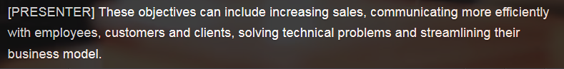















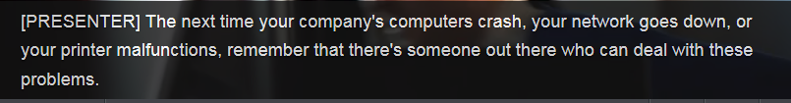



# Part 2)

## PC hardware

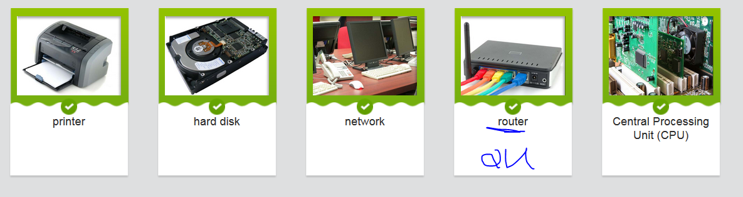

* The hard disk has a capacity of 80 gigabytes.
* The 'n' on this keyboard doesn't work.
* This CPU is powerful enough to run multiple software programs at the same time.
* There are 35 devices on this corporate network .
* An optical drive光盘 stores large amounts of data on a single disk.
* The printer needs a new ink cartridge.
* This printer needs a new toner cartridge.

## Set up Your New Desktop PC-Following user manual instructions

|  |
| --- |
| https://cns2.ef-cdn.com/Juno/10/85/79/v/108579/IT1.2.2.2-640.jpg |
| After purchasing and taking home your new system, you need to set it up properly.  Choose a place that is not damp and that does not get direct exposure from the sun.  Make sure there is **a power outlet**电源插座nearby. If you have **cable Internet access**, you also need to be able to connect to **coaxial cable/line [kəʊ'æksɪəl]同轴电缆**  First, **unpack** your computer, monitor and printer carefully then place them on a stable desk or table. Don't put the computer on the floor, as it will **suck in dust**吸灰, causing **premature malfunction of components会造成电脑零部件的“提早”失效**. **//premature: happen before the natural or the expectedly planned time过早的，提早的**  Once everything is in position, **plug the “electrical surge protector” into** the wall and turn the switch off. **Plug the computer and monitor in** immediately to **discharge any static electricity** that may cause damage as you touch the various connectors. Make sure the computer and monitor are switched OFF after connecting.   Connect the mouse and keyboard to the back of the computer into the proper connectors. Usually they are color-coded. Do not rotate and push those connectors - this may cause damage that is not covered by the **warranty〔产品的〕保修单.** Instead, carefully align them before inserting them.  Next, connect the monitor to the back of the computer. Do not connect the printer until you have installed **the printer drivers**.   You are now ready to turn on the computer.   If you have **cable Internet access**, connect the **coaxial cable/line [kəʊ'æksɪəl]同轴电缆**to the **cable modem** and the **cable modem** to the Ethernet port of your computer. There should be **“electrical surge” protection** on the cable side of the modem.   Follow any directions from your ISP to set up your Internet connection and service.  Finally, remember to store your disks that came with the computer in a safe place where you can find them. They may be important in the future. |

|  |
| --- |
| IT SUPPORT: Hello, IT Support Center. **How may I help you**?  CUSTOMER: Hi, **I'm having a problem with** my computer. I can't seem to access the Internet.  IT SUPPORT: I see . What type of Internet connection do you use? **Cable modem**?  CUSTOMER: Yes, cable modem.  IT SUPPORT: Well it could be that there's a problem with your modem connection. Have you checked the user manual to see that **the coaxial cable/line** is connected to your modem, and that the modem is connected to the Ethernet port of your computer?  CUSTOMER: Yes, that's all fine. I followed those instructions pretty carefully when I **set it up.**  IT SUPPORT: Hmmm, maybe your cable modem is turned off then. Have you tried turning it on again?  CUSTOMER: Yep, I've done that, and the power light is definitely on.  IT SUPPORT: OK, it could be that your Internet connection is disabled.  CUSTOMER: Oh ok. So how can I check that?  IT SUPPORT: If you open the Network and Sharing Center in Control Panel, and then click on Manage Network Connections, it should tell you whether your Local Area Connection is enabled.  CUSTOMER: OK, **hold on a second.** (pause, mouse clicking…..)Yeah, you were right! I don’t know why, but my Local Area Connection is disabled.  IT SUPPORT: **In that case** , just right-click the Local Area Connection icon, and then select Enable.  CUSTOMER: Ah great, it's working now. I must’ve **inadvertently** disabled the connection. Thanks a lot! **//on purpose/deliberately/intentionally V.S. inadvertently** IT SUPPORT: No problem, glad to help. |

# Part 3) Describe what a job entails一个工作包含什么

This person designs, develops, tests and evaluates computer software. **Additionally** , this person looks for ways to improve the performance and reliability of existing software.   
  
**This position involves** designing, implementing, maintaining, and repairing an organization’s database. Specifically, a database administrator will install new databases, set up login credentials for authorized users, and define access privileges.  
   
An employee who writes computer software. **Specifically**, computer programmers write, test, and debug computer programs. This person is usually either a specialist (specializing in one area of programming) or a generalist (writing code for many kinds of software).   
  
A person whose job it is to research problems, plan IT solutions, recommend software and hardware systems, and coordinate development to meet business objectives. A systems analyst is an expert in problem-solving, and is familiar with programming languages and operating systems.  
   
A person who **is responsible for/in charge of** maintaining computer hardware and software in a computer network. In accordance with their duties , a network administrator will obtain new hardware, schedule new software updates, maintain network connectivity, keep track of software licenses, and maintain and deploy servers.

## Expressing future possibilities for a job

* We'll be seeing more job losses this year.
* Companies will turn more and more to outsourcing.=> which makes the IT job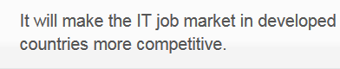
* China will have seen **a surge in growth 激增**by next year.
* Certain skills will see an increase in demand.
* Network security will be among the top IT fields.

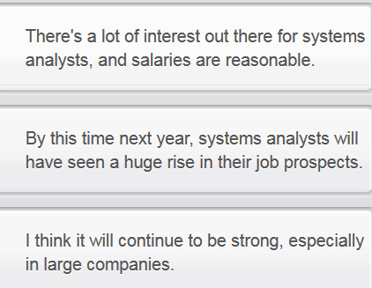 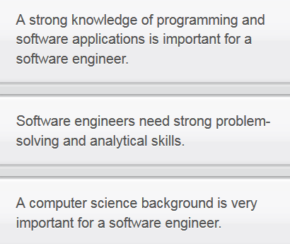

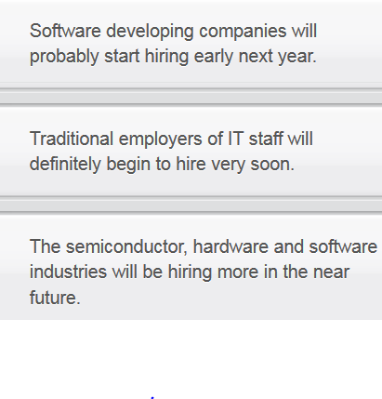







## Introducing careers in IT

You and another colleague have been asked to give a talk about careers in the IT industry to a group of computer science students. Listen to your colleague first then present a similar talk about your role in IT. If you don't work in IT, use the text to give you some ideas.

Software engineer

* Designs, tests, and develops software
* Helps improve performance of software
* Responsible for attending planning meetings with management

Systems analyst

* In charge of researching problems and providing solutions
* Responsible for recommending new software and hardware
* Familiar with operating systems and computer programming

# STOP

# Part4) Website design

**Purpose**   
To create brand awareness, obtain a favorable public image, and increase sales of our new cat food product. The purpose of the website is to increase sales.

**SEO (search engine optimization)**  
Before we create the content, we need to insert keywords and alter meta tags in the website code that help. Search engine optimization is important for the site.

**List of pages**   
We require a home page, a page about the company, a page about the product, a links page of distributors and wholesalers, a page of testimonials by satisfied customers, and a contact page. We need to include a home page and a contact page.

**Text**  
This will be the text in the website. Please copy and paste the exact text given to you on the appropriate pages of the website. Do not edit or change any of the text.

**Graphics**   
Use photos of different cats as icons on the navigation bar located on the top of the website. Use animated graphics whenever possible. Make sure to have at least one or two shots of the product on each page. For the graphics, be sure to include clear icons

**Sounds**   
Insert random cat noises when users click on icons to navigate to the various pages. Instruct users to turn on their computer speakers when browsing the site for best performance.

**Links**   
After the content is finished, we need to include websites of our distributors and wholesalers. Specifically, include a list of stores that carry our product, and their websites. Include links to the sites of our distributors.

**Further instructions**   
Make sure to design the site so that it loads quickly in web browsers. Do not use forms, as they slow down website load times. Use an easy-to-read, serif font. Include the company email address and phone number on every page.

## IM(instant message) short forms

You're about to read a text chat between two colleagues. Before doing so, match the acronyms and short forms to their fullly written meanings.

|  |
| --- |
| amie: hi, u back from the meeting yet? Alan: y, what’s up? Jamie: r u busy? need to ask u a favor Alan: np Jamie: thx! Can u plz browse a webpage 2 C if it brings up a password window? The URL is www… Alan: trying it now… Jamie: great! I can’t find anyone else to try this 4 me Alan: ur welcome Alan: it’s thinking… Alan: probably doing the dns lookup Jamie: FYI did u hear what happened to Jim yesterday? Alan: ? Jamie: we got a visit from the CEO and Jim mistook her for the new temp! Alan: LOL, he always puts his foot in it, doesn’t he! Alan: OK, if I go to /name/, it asks for a passwd Alan: if I try /name/program.exe, it just sits there Jamie: just a sec, BRB Alan: TTYL Jamie: back now Alan: BTW, is this apache authentication? Jamie: no idea - all thru a web UI to my webhosting service. Alan: I C Jamie: mine is sitting there too now Alan: u know, I think Brad knows more about this. Should we do a 3-way?  ***Alan added Brad to conversation*** Alan: hey Brad, have a sec? we need **an html guru/technical savvy大牛**! Brad: sorry, on the line to Boston. |

## Advising on a website design spec

You are a website designer. Read the email from your manager summarizing a client's spec. Before you start on the project, you want to make sure the client has covered all possible areas.

Hi,

I just talked to the client and here’s what he wants us to do. First of all, he wants us to include only small images (smaller than 200 x 200 pixels) on the front page. He thinks that large images would distract visitors. He wants clients to focus more on the texts, since that’s where they will learn more about the product. Also, he would like to have sounds that correspond to the icons that customers click on. Make sure that the sounds work on the most popular browsers.

Additionally, he would like us to include links to all of their subsidiaries on the Links page, since that will drive business to the other sites as well. Oh, and he thinks the site will look better if we use the Georgia font. It’s more pleasing to the eye. Finally, he says we can go ahead and include a paragraph about the 60-day money-back guarantee on the product page. This is a unique selling point of their product.

I hope this makes sense. If you have any questions, don’t hesitate to get in touch with me right away.

Thanks,

Rick

## Writing:

Write an email to the client, informing them of the sections that you have not yet received information on, highlight the importance of the information and request that it be provided as soon as possible. Use the notes to help you. Write 150-200 words.

Begin the email: Dear client, I have just received information regarding your website design spec...

* Purpose: What is the aim or objective of the website? What does the client hope to achieve in the end?
* List of pages: Company page? Product page? Testimonial? Which pages does the client want included?
* SEO: Keywords and meta tagging will make site easier to navigate for user and easier to find in search engine.

